LAPORAN PENGERJAAN UJI KOMPETENSI KEJURUAN

SMK MAHARDHIKA BATUJAJAR

TAHUN PELAJARAN 2022-2023

KOMPETENSI KEAHLIAN : Rekayasa Perngkat Lunak KELAS : XII RPL 1

NAMA LENGKAP : Suci Nurrohmah Hudayanti

NIS : 2021.10.347

PAKET SOAL : 02

JENIS APLIKASI : Web

ALOKASI WAKTU : 24 jam

# PENJADWALAN KEGIATAN

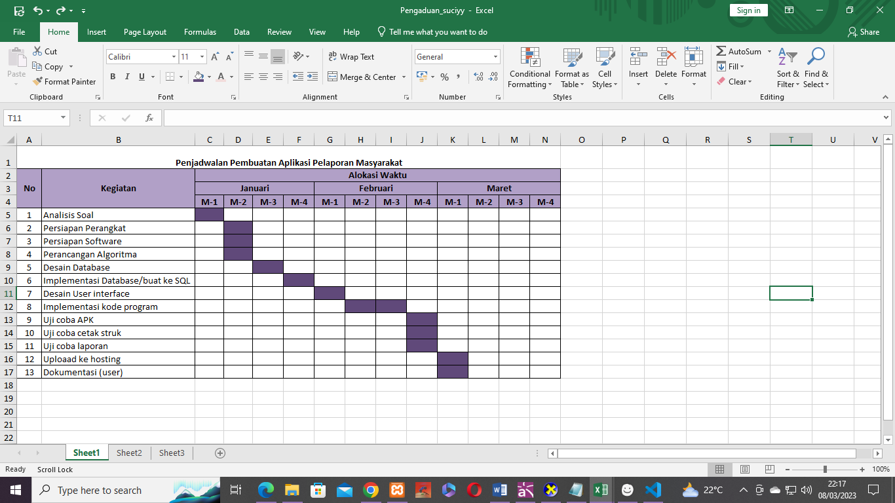

# PERSIAPAN PERANGKAT KERAS

* Device name : DESKTOP-HIJ3FFL
* Processor : AMD Phenom(tm) II X4 965 Processor (4 CPUs), ~3.4GHz
* Memory : 6144MB RAM

# PERSIAPAN PERANGKAT LUNAK

* Xampp Control Panel
* Google Chrome
* Visual Studio Code
* Microsoft Edge
* Microsoft word
* Astah Pro
* Balsamiq Mockup
* Mysql

# PERANCANGAN ALGORITMA APLIKASI

1. Activity Diagram Daftar Masyarakat 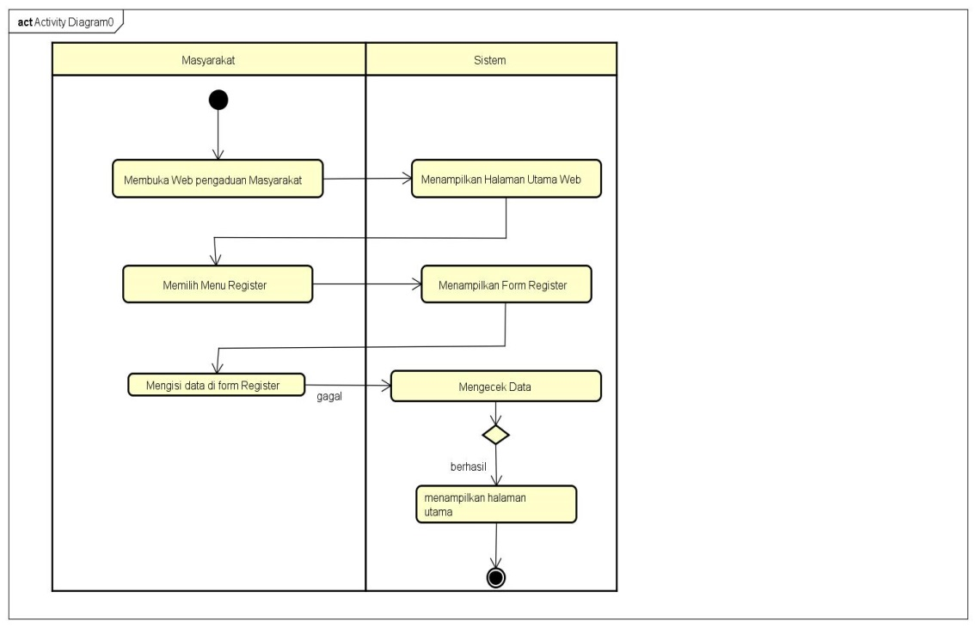
2. Activity Diagram Login Masyarakat, Petugas, Admin 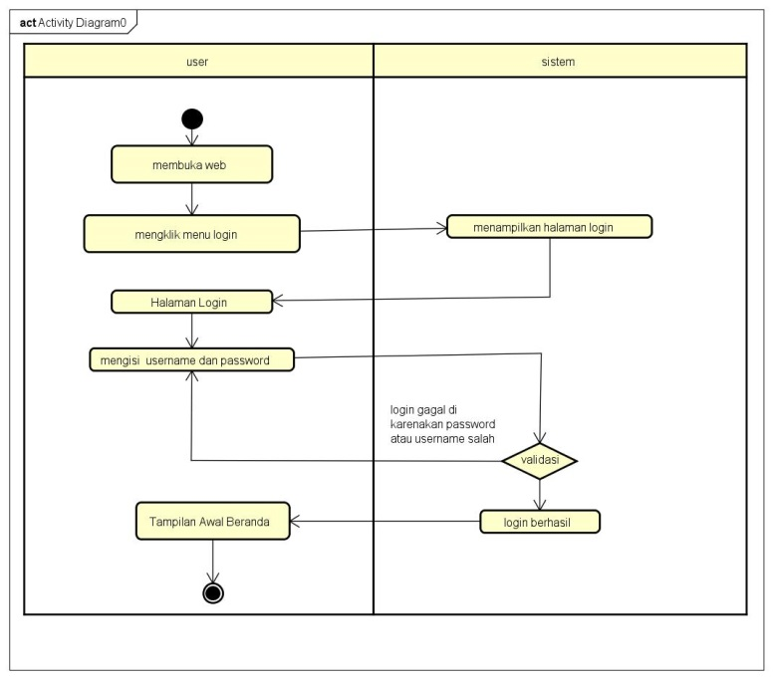
3. Activity Diagram Laporan Pengaduan

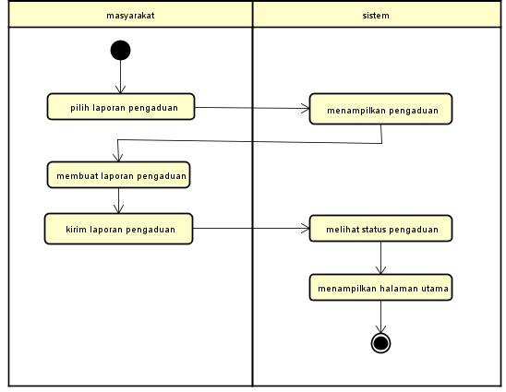

1. Activity Diagram Tanggapan laporan

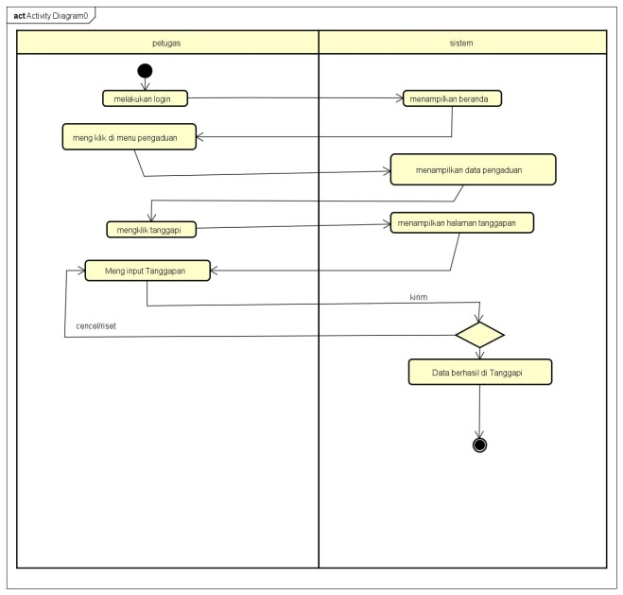

1. Activity Diagram Hapus Pengaduan

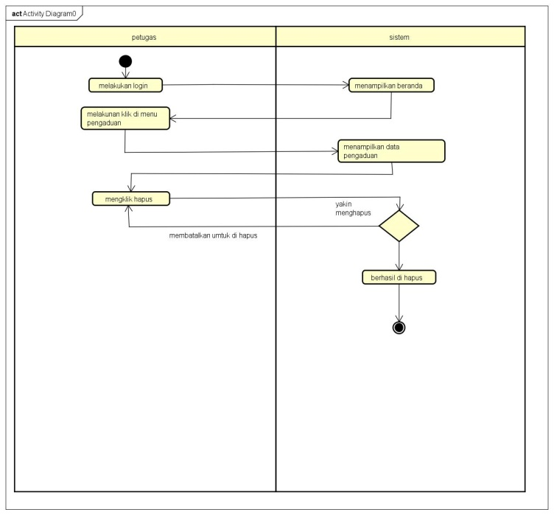

1. Activity Diagram Update

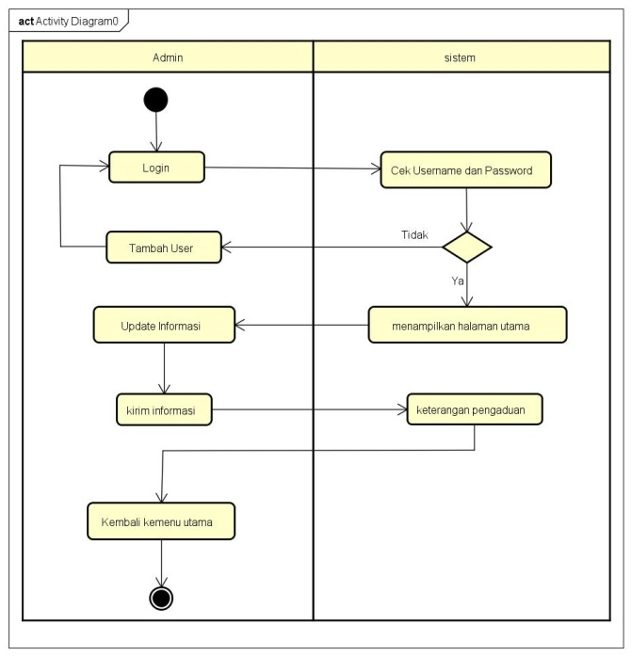

1. Activity Diagram Cek Laporan

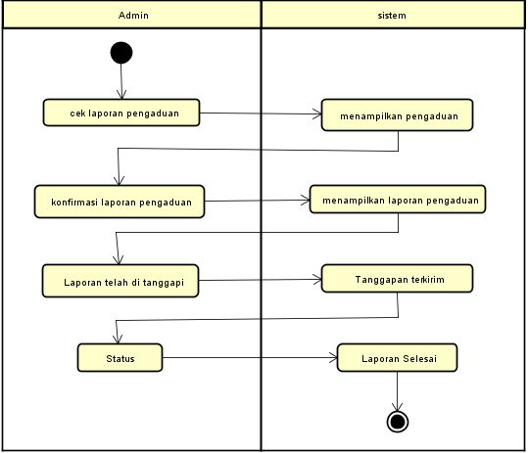

1. Activity Diagram Cetak Laporan

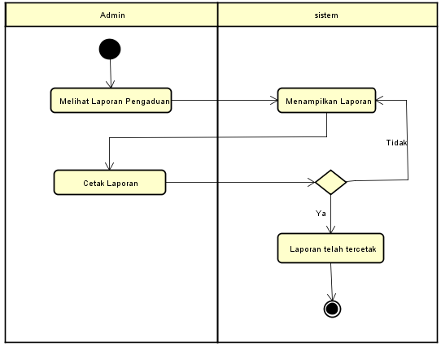

1. Activity Diagram Logout

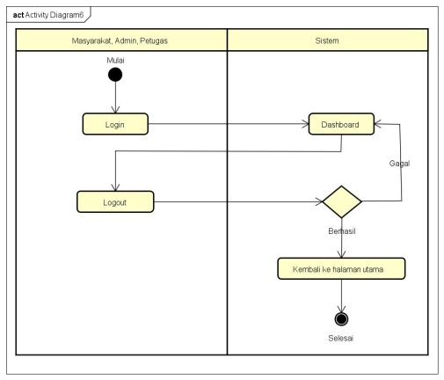

# PERANCANGAN DESAIN BASIS DATA

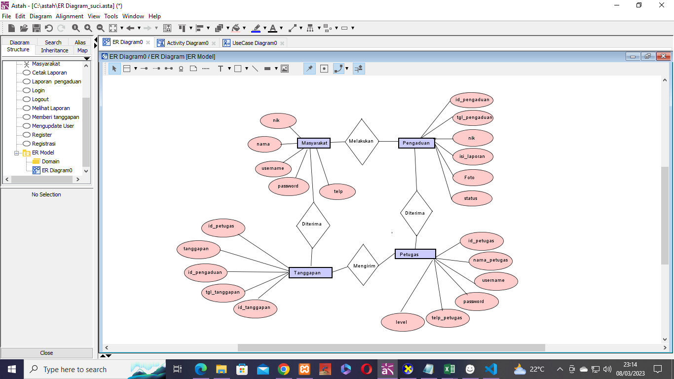

# DUMMY DATA

* **Data Masyarakat**

|  |  |  |  |  |
| --- | --- | --- | --- | --- |
| **Nik** | **Nama** | **Username** | **Password** | **telp** |
| 0001234 | Fallen | Fallen11 | 9999 | 0856748392345 |
| 0001235 | Suci Nurrohmah | Vanilla | 1111 | 0886785432546 |
| 0001236 | Nalisa | Sasa | 2222 | 0887654324534 |
| 0001237 | Safitri | fitriy | 3333 | 0889765453678 |
| 0001238 | Rehan | hans | 6666 | 0987656897564 |

* **Data Petugas**

|  |  |  |  |  |  |
| --- | --- | --- | --- | --- | --- |
| **Id_Petugas** | **Nama_Petugas** | **Username** | **Password** | Telp_Petugas | **Level** |
| 123455 | Suci Hudayanti | Sunny | 3455 | 0858758495867 | Petugas |
| 123456 | Topan Alfatah | Angin12 | 2323 | 0987654767809 | Petugas |
| 123457 | Caca Marica | Marica3 | 3434 | 0876875646578 | Petugas |
| 123458 | Shilla Nurmala | Nurmala22 | 2121 | 0878909786745 | Petugas |
| 123459 | Pitri Ayu | Ayuu21 | 3211 | 0987654567890 | Petugas |

* **Data Admin**

|  |  |  |  |  |  |
| --- | --- | --- | --- | --- | --- |
| **Id_Admin** | **Nama_Admin** | **Username** | **Password** | Telp_Admin | **Level** |
| 1234560 | Rere Tulip | Flower | 1111 | 0858758495867 | Admin |
| 1234561 | Rayanza | Rayan00 | 9998 | 0987657654678 | Admin |
| 1234572 | Wandari | Awan45 | 4545 | 0989893475973 | Admin |
| 1234583 | Tania | Langit09 | 2121 | 0878909745632 | Admin |
| 1234595 | Nurul | Nuruly | 4433 | 0987682746596 | Admin |

# PEMBUATAN BASIS DATA (MySQL Code)

# Masyarakat

# 

# Pengaduan

# 

# Petugas

# 

# Tanggapan

# 

# PERANCANGAN TAMPILAN ANTARMUKA (UI) WEB

* + **Aplikasi pengaduan masyarakat**

1. Use Case Diagram

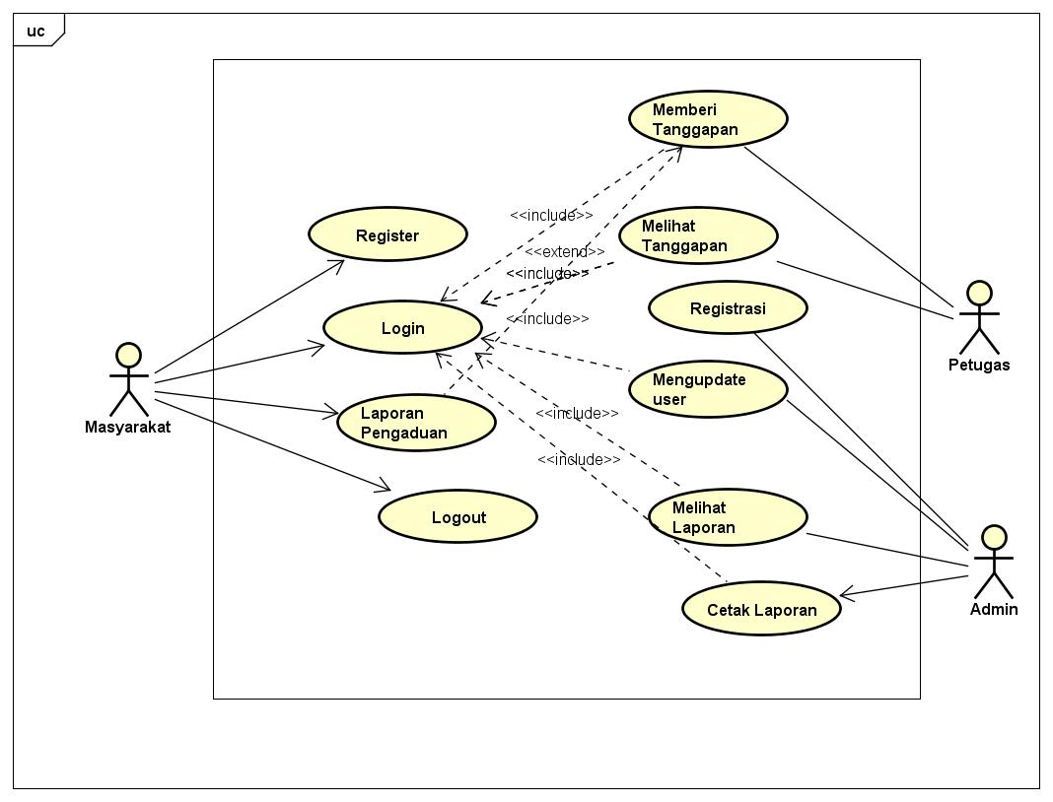

1. Dashboard Admin

* Dashboard Admin

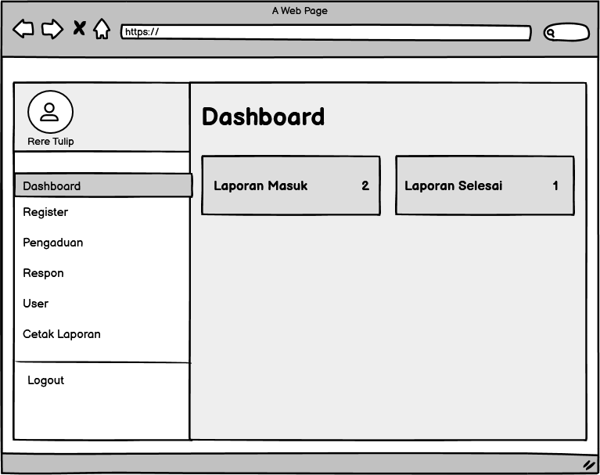

* Registrasi

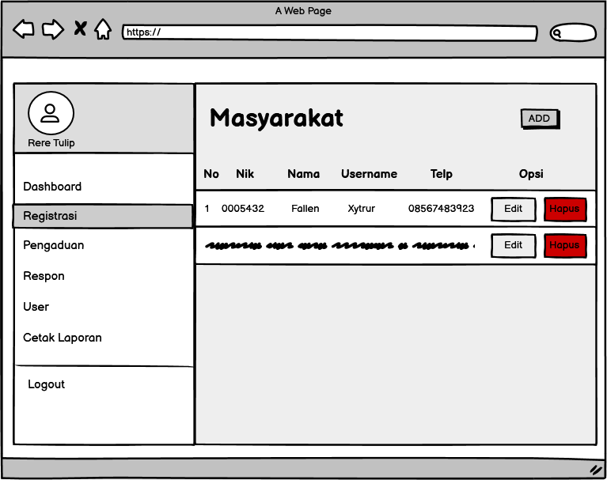

* Pengaduan

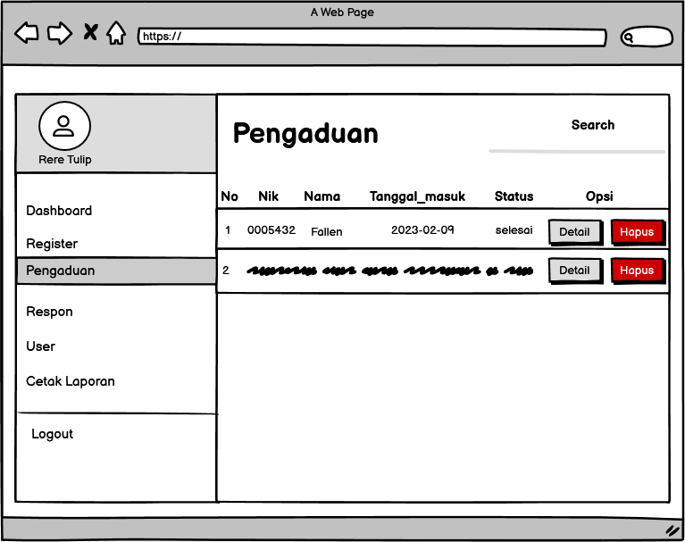

* Respon

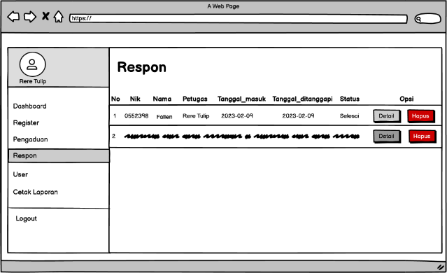

* User

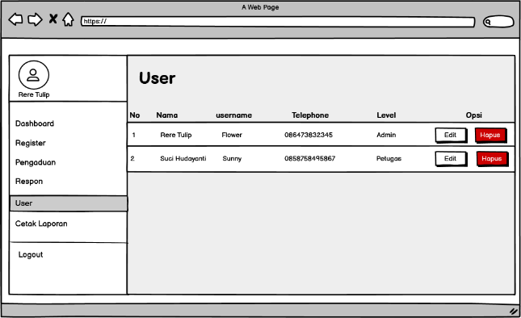

* Generate Laporan

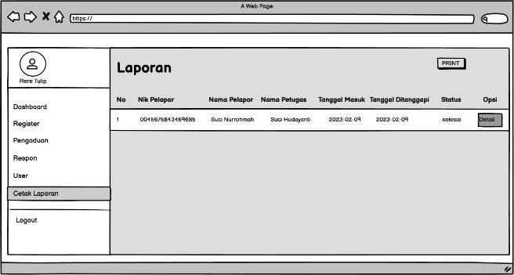

1. Tampilan Petugas

* Dashboard

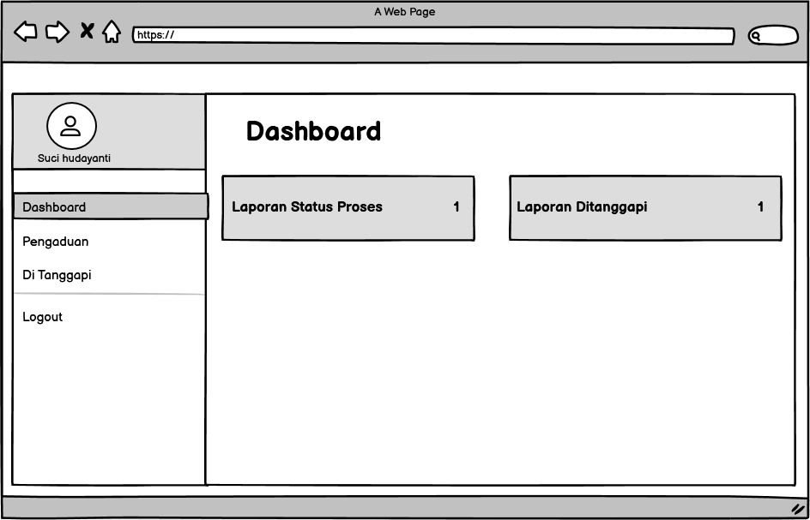

* Pengaduan

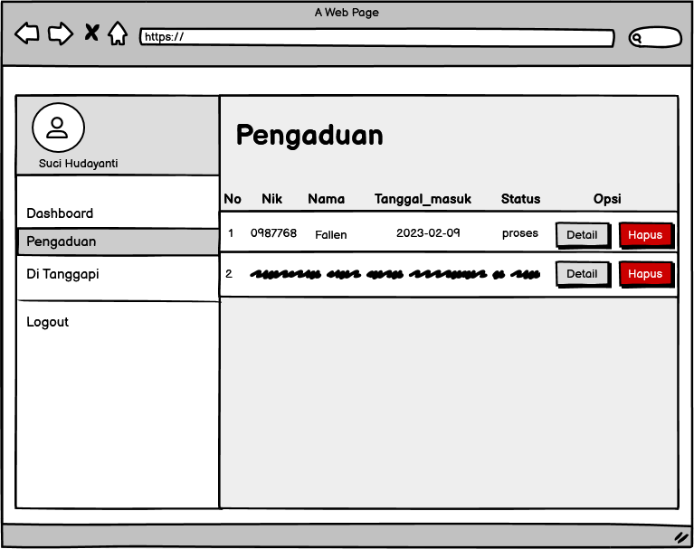

* Di Tanggapi/Respon

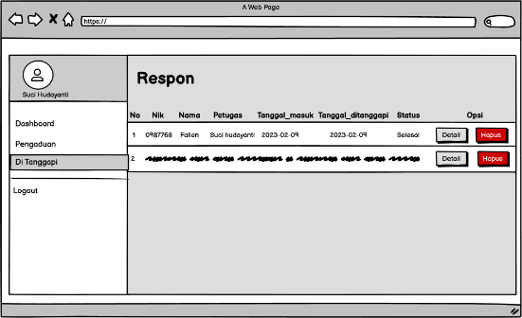

1. Tampilan Masyarakat

* Dashboard

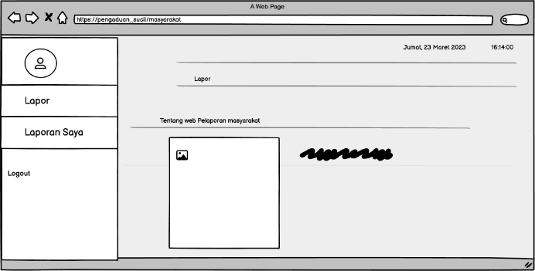

* Lapor

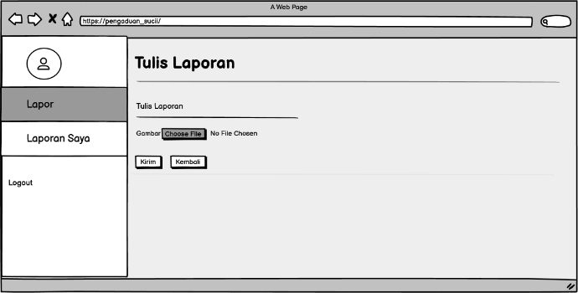

* Pengaduan Saya

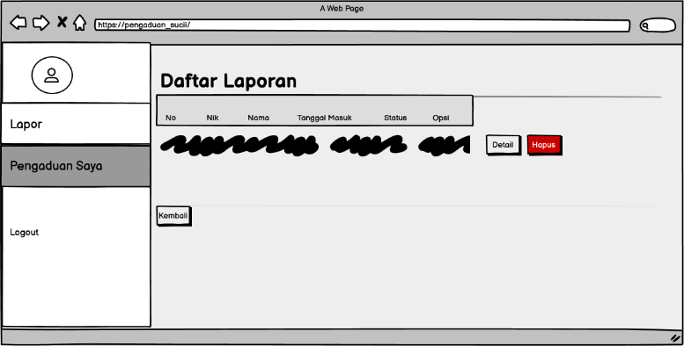

1. PEMBUATAN STYLE WEB (CSS)

* Slick.css

|  |
| --- |
| /* Slider */  .slick-slider  {  position: relative;  display: block;  box-sizing: border-box;  -webkit-user-select: none;  -moz-user-select: none;  -ms-user-select: none;  user-select: none;  -webkit-touch-callout: none;  -khtml-user-select: none;  -ms-touch-action: pan-y;  touch-action: pan-y;  -webkit-tap-highlight-color: transparent;  }  .slick-list  {  position: relative;  display: block;  overflow: hidden;  margin: 0;  padding: 0;  }  .slick-list:focus  {  outline: none;  }  .slick-list.dragging  {  cursor: pointer;  cursor: hand;  }  .slick-slider .slick-track,  .slick-slider .slick-list  {  -webkit-transform: translate3d(0, 0, 0);  -moz-transform: translate3d(0, 0, 0);  -ms-transform: translate3d(0, 0, 0);  -o-transform: translate3d(0, 0, 0);  transform: translate3d(0, 0, 0);  }  .slick-track  {  position: relative;  top: 0;  left: 0;  display: block;  margin-left: auto;  margin-right: auto;  }  .slick-track:before,  .slick-track:after  {  display: table;  content: '';  }  .slick-track:after  {  clear: both;  }  .slick-loading .slick-track  {  visibility: hidden;  }  .slick-slide  {  display: none;  float: left;  height: 100%;  min-height: 1px;  }  [dir='rtl'] .slick-slide  {  float: right;  }  .slick-slide img  {  display: block;  }  .slick-slide.slick-loading img  {  display: none;  }  .slick-slide.dragging img  {  pointer-events: none;  }  .slick-initialized .slick-slide  {  display: block;  }  .slick-loading .slick-slide  {  visibility: hidden;  }  .slick-vertical .slick-slide  {  display: block;  height: auto;  border: 1px solid transparent;  }  .slick-arrow.slick-hidden {  display: none;  } |

1. PEMBUATAN KODE WEB (PHP/JS)

* Index.php

|  |
| --- |
| <!doctype html>  <html class="no-js" lang="zxx">  <head>  <meta charset="utf-8">  <meta http-equiv="x-ua-compatible" content="ie=edge">  <title>HOME</title>  <meta name="description" content="">  <meta name="viewport" content="width=device-width, initial-scale=1">  <!-- <link rel="manifest" href="site.webmanifest"> -->  <link rel="shortcut icon" type="image/x-icon" href="img/homeicon.jpg">  <!-- Place favicon.ico in the root directory -->  <!-- CSS here -->  <link rel="stylesheet" href="css/bootstrap.min.css">  <link rel="stylesheet" href="css/owl.carousel.min.css">  <link rel="stylesheet" href="css/magnific-popup.css">  <link rel="stylesheet" href="css/font-awesome.min.css">  <link rel="stylesheet" href="css/style.css">  <!-- <link rel="stylesheet" href="css/responsive.css"> -->  </head>  <body style="background: url(img/ss.jpg); background-size: cover;">  <!-- header-start -->    <header>  <div class="header-area purple ">  <div class="header-top_area d-none d-lg-block purple">  <div class="container">  <div class="row">  <ul>  <li id="date"><strong><font color="purple">Selasa, 28 Februari 2023</font></strong></li>  <li id="clock">10:00:00 AM</li>  </ul>    </div>  </div>  </div>  <div id="sticky-header" class="main-header-area">  <div class="container">  <div class="header_bottom_border ">  <div class="row align-items-center">  <div class="col-xl-3 col-lg-2">  <div class="logo">  <a href="index.php">  <img src="img/logo desa.png" alt="">  </a>  </div>  </div>  <div class="col-xl-6 col-lg-7">  <div class="main-menu d-none d-lg-block">  <nav>  <ul id="navigation purple">  <i class="fa fa-home" style="color:white"><li><a class="active" href="index.php">Home</a></li></i>&nbsp;      </div>  <div class="col-12">  <div class="mobile_menu d-block d-lg-none"></div>  </div>  </div>  </div>  </div>  </div>  </div>  </header>  <!-- header-end -->  <!-- slider_area_start -->  <div class="slider_area">  <div class="slider_active owl-carousel">  <div class="single_slider d-flex align-items-center slider_bg_2 overlay2">  <div class="container">  <div class="row">  <div class="col-xl-12">  <div class="slider_text">  <h3> Web Pelaporan<br>  Pengaduan Masyarakat</h3>  <p>Selamat datang di web Pengaduan Masyarakat<br>  Silahkan Registrasi dan Login dengan akun anda.</p>  <div class="video_service_btn">  <a href="register.php" class="boxed-btn3"><i class="fa fa-user-plus"> Registrasi disini</i></a>  <a href="lo.php" class="boxed-btn3 purple"> <i class="fa fa-sign-in"></i>  Login</a>  </div>  </div>  </div>  </div>  </div>  </div>  <div class="single_slider d-flex align-items-center slider_bg_1 overlay2">  <div class="container">  <div class="row">  <div class="col-xl-12">  <div class="slider_text ">  <h3> Web Pelaporan<br>  Pengaduan Masyarakat</h3>  <p>Selamat datang di web Pengaduan Masyarakat<br>  Silahkan Registrasi dan Login dengan akun anda.</p>  <div class="video_service_btn">  <a href="register.php" class="boxed-btn3"><i class="fa fa-user-plus"> Registrasi disini</i></a>  <a href="lo.php" class="boxed-btn3 purple"><i class="fa fa-sign-in"></i>  Login </a>  </div>  </div>  </div>  </div>  </div>  </div>  <div class="single_slider d-flex align-items-center slider_bg_3 overlay2">  <div class="container">  <div class="row">  <div class="col-xl-12">  <div class="slider_text ">  <h3> Web Pelaporan<br>  Pengaduan Masyarakat</h3>  <p>Selamat datang di web Pengaduan Masyarakatn<br>  Silahkan Registrasi dan Login dengan akun anda.</p>  <div class="video_service_btn purple">  <a href="register.php" class="boxed-btn3"><i class="fa fa-user-plus"> Registrasi disini</i></a>  <a href="lo.php" class="purple boxed-btn3 "><i class="fa fa-sign-in"></i>  Login </a>  </div>  </div>  </div>  </div>  </div>  </div>  </div>  </div>    <!-- slider_area_end -->  <!-- service_area_start -->  <!-- project -->  <!--/ project -->  <!-- footer start -->  <footer class="footer">    </div>  <div class="copy-right_text">  <div class="container">  <div class="footer_border"></div>  <div class="row">  <div class="col-xl-12">  <p class="copy_right text-center">  <!-- Link back to Colorlib can't be removed. Template is licensed under CC BY 3.0. -->  <!-- Link back to Colorlib can't be removed. Template is licensed under CC BY 3.0. -->  </p>  </div>  </div>  </div>  </div>  </footer>  <!--/ footer end -->  <!-- JS here -->  <script src="js/vendor/modernizr-3.5.0.min.js"></script>  <script src="js/vendor/jquery-1.12.4.min.js"></script>  <script src="js/popper.min.js"></script>  <script src="js/bootstrap.min.js"></script>  <script src="js/owl.carousel.min.js"></script>  <script src="js/isotope.pkgd.min.js"></script>  <script src="js/ajax-form.js"></script>  <script src="js/waypoints.min.js"></script>  <script src="js/jquery.counterup.min.js"></script>  <script src="js/imagesloaded.pkgd.min.js"></script>  <script src="js/scrollIt.js"></script>  <script src="js/jquery.scrollUp.min.js"></script>  <script src="js/wow.min.js"></script>  <script src="js/nice-select.min.js"></script>  <script src="js/jquery.slicknav.min.js"></script>  <script src="js/jquery.magnific-popup.min.js"></script>  <script src="js/plugins.js"></script>  <script src="js/gijgo.min.js"></script>  <script src="js/slick.min.js"></script>  <!--contact js-->  <script src="js/contact.js"></script>  <script src="js/jquery.ajaxchimp.min.js"></script>  <script src="js/jquery.form.js"></script>  <script src="js/jquery.validate.min.js"></script>  <script src="js/mail-script.js"></script>  <script src="js/main.js"></script>  <script type="text/javascript">  // Menampilkan Jam  function showTime() {  var a_p = "";  var today = new Date();  var curr_hour = today.getHours();  var curr_minute = today.getMinutes();  var curr_second = today.getSeconds();  if (curr_hour < 12) {  a_p = "AM";  } else {  a_p = "PM";  }  if (curr_hour == 0) {  curr_hour = 12;  }  if (curr_hour > 12) {  curr_hour = curr_hour - 12;  }  curr_hour = checkTime(curr_hour);  curr_minute = checkTime(curr_minute);  curr_second = checkTime(curr_second);  document.getElementById('clock').innerHTML=curr_hour + ":" + curr_minute + ":" + curr_second + " " + a_p;  }  function checkTime(i) {  if (i < 10) {  i = "0" + i;  }  return i;  }  setInterval(showTime, 500);    var months = ['Januari', 'Februari', 'Maret', 'April', 'Mei', 'Juni', 'Juli', 'Agustus', 'September', 'Oktober', 'November', 'Desember'];  var myDays = ['Minggu', 'Senin', 'Selasa', 'Rabu', 'Kamis', 'Jum&#39;at', 'Sabtu'];  var date = new Date();  var day = date.getDate();  var month = date.getMonth();  var thisDay = date.getDay(),  thisDay = myDays[thisDay];  var yy = date.getYear();  var year = (yy < 1000) ? yy + 1900 : yy;  document.getElementById('date').innerHTML=thisDay + ', ' + day + ' ' + months[month] + ' ' + year;  </script>  </body>  </html> |

* Koneksi.php

|  |
| --- |
| <?php $koneksi=mysqli_connect("localhost","root","","pengaduan_masyarakat"); ?> |

**Crud File**

* Register.php

|  |
| --- |
| <html>  <head>  <link rel="stylesheet" type="text/css" href="style.css">  <!-- ICONS -->  <link rel="icon" type="image/png" href="img/homeicon.ico"/>  <link rel="icon" type="image/png" sizes="96x96" href="img/homeicon.jpg">  <title>Aplikasi Pengaduan Masyarakat</title>  <style type="text/css" media="screen">  @import url('https://fonts.googleapis.com/css?family=PT+Sans');  body{  background: url(img/ss.jpg);  background-size: cover;  background-position: center;  background-repeat: no-repeat;  font-family: sans-serif;  font-size: 10px  }  h1{  font-size:"10px";  color: white;  }  h2{  padding-top: 1.5rem;  }  .container{  position: absolute;  left: 50%;  top: 50%;  transform: translate(-50%,-50%);  padding: 40px 100px;  width: 500px;  background: url(img/polos.jpg);  background-size: cover;  box-shadow: 0 0 20px rgba(255,255,255,.3);    }  font{  font-size: 20px;  }  .submit{  background: purple;  color: white;  font-size: 11pt;  width: 50%;  border: none;  border-radius: 20px;  padding: 10px 20px;  }  .reset{  background: purple;  color: white;  font-size: 10pt;  width: 50%;  border: none;  border-radius: 20px;  padding: 10px 20px;  }  .kembali{  background: purple;  color: white;  font-size: 10pt;  width: 50%;  border: none;  border-radius: 20px;  padding: 10px 20px;  }  </style>  </head>  <body background = "langit.jpg">  <div style="border:0; padding:10px; width:760px; height:auto;">  <form class="container" action="proses.php" method="POST" name="proses">  <h1 align="center">DAFTAR AKUN MASYARAKAT </h1>  <table width="500" border="0" align="center" cellpadding="0" cellspacing="0">  <tr height="46">  <td width=""> </td>  <td width=""> </td>  </tr>  <tr height="46" >  <td> </td>  <td><font color="white">NIK</font></td>  <td><input type="text" name="nik" size="23" required/></td>  </tr>  <tr height="46">  <td> </td>  <td><font color="white">Nama</font></td>  <td><input type="text" name="nama" size="23" required/></td>  </tr>    <tr height="46">  <td> </td>  <td><font color="white">Username</font></td>  <td><input type="text" name="username" size="23" required/></td>  </tr>  <tr height="46">  <td> </td>  <td><font color="white">Password</font></td>  <td><input id="password" type="password" name="password" size="23" required/></td>  </tr>  <tr height="46">  <td> </td>  <td><font color="white">No_Telepon</font></td>  <td><input type="text" name="telp" size="23" required/></td>  </tr>  <tr>  <td></td>  <td><input type="submit" name="Submit" value="Submit" class="Submit" style="width: 29%;" />&nbsp; <input type="reset" name="reset" value="Reset" class="reset" style="width: 29%;" />  <a href="index.php" class="kembali" style="width: 29%;" >Kembali</a>  </tr>  </table>  </form>  </div>  </body>  </html> |

* Proses.php

|  |
| --- |
| ?php  include "conn/koneksi.php";  if ($_POST['Submit'] == "Submit") {  $nik =$_POST['nik'];  $nama =$_POST['nama'];  $username=$_POST['username'];  $password =$_POST['password'];  $telp =$_POST['telp'];    $ceknik =mysqli_num_rows (mysqli_query($koneksi, "SELECT nik FROM masyarakat WHERE nik='$_POST[nik]'"));    if($ceknik > 0) {  ?>  <script language="JavaScript">  alert('NIK sudah di gunakan...');  document.location='register.php';  </script>  <?php  }    else{  $insert =mysqli_query($koneksi, "INSERT INTO masyarakat (nik, nama, username, password, telp) VALUES ('$nik', '$nama', '$username', '$password', '$telp')");  ?>  <script language="JavaScript">  alert('Daftar Akun Berhasil ...');  document.location='index.php';  </script>  <?php  }  }  ?> |

1. UJI COBA

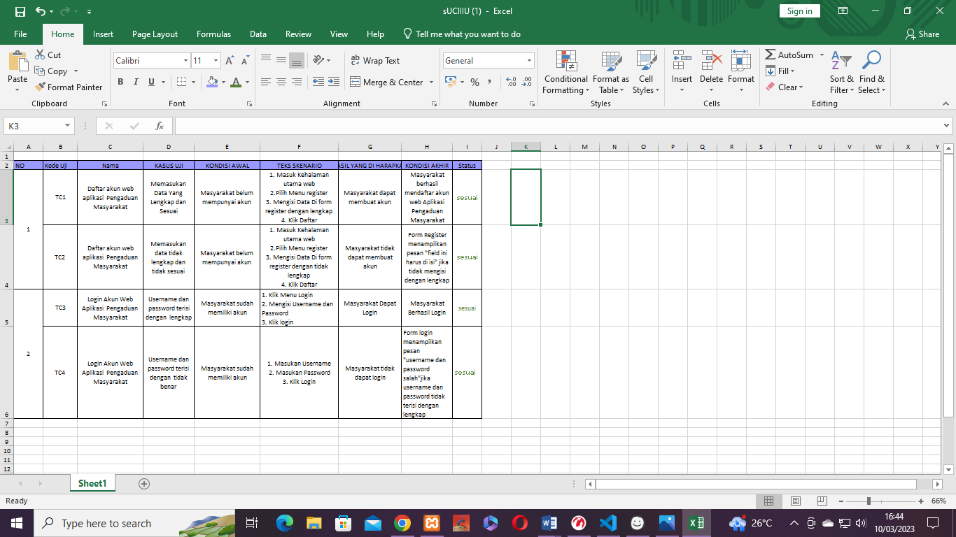

1. REVISI

|  |
| --- |
|  |

1. PENENTUAN DOMAIN DAN HOSTING
2. UPLOAD WEB KE HOSTING
3. UPLOAD WEB KE GITHUB
4. PEMBUATAN USER GUIDANCE